**Assignment**

Student number: 12161762

Name: LEE YEONG JUN

<Code>

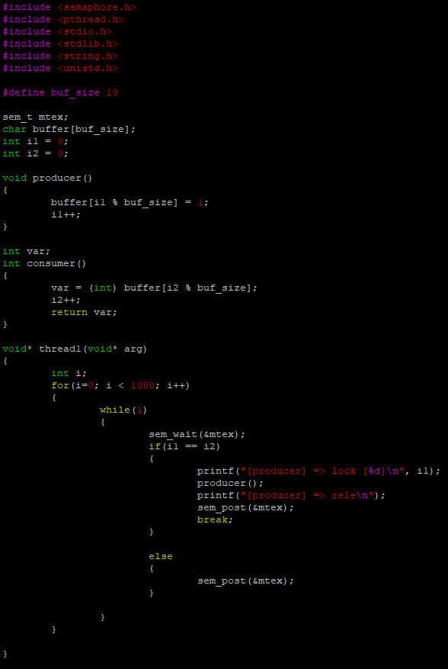

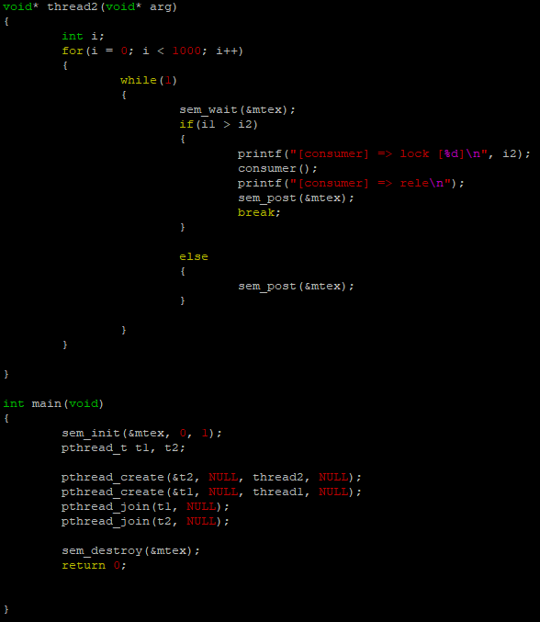

<Result>



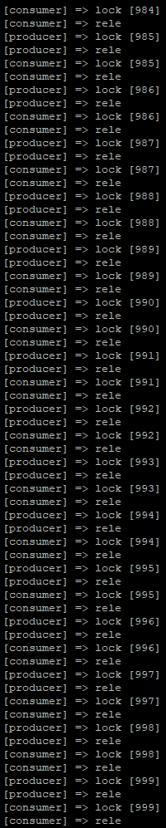

A semaphore is created with the name ‘mtex’, and the number of data to process is set to 1000. i1 is the number of data stored, and i2 is the number of data consumed. ‘sem_wait’ prevents the access of two threads at the same time, and decreases the semaphore value by 1. If i1 is equal to i2, the producer is executed, and if i1 is greater than i2, the consumer is executed. ‘sem_post’ increases the semaphore value by 1. In the code above, the semaphore value is initialized to 1, so the semaphore value is reduced from 1 to 0 in ‘sem_wait’, and the semaphore value is increased from 0 to 1 in ‘sem_post’.